[View Attendance for Student]

Technical Document

Date: 13/Feb/2019

Version: Version 0.1

# Table of Contents

Table of Contents 1

[View Attendance For Instructor] 2

Description 2

1.1 Mockup screen: 2

1.2 Angular & Spring Models 2

1.3 Angular Component 3

1.4 Rest Services 3

1.5 Repository Functions 3

# 

# [View Attendance for Instructor]

Refer to: [Taiga URL]

## Description

View Attendance Student For Instructor .

## Mockup screen:

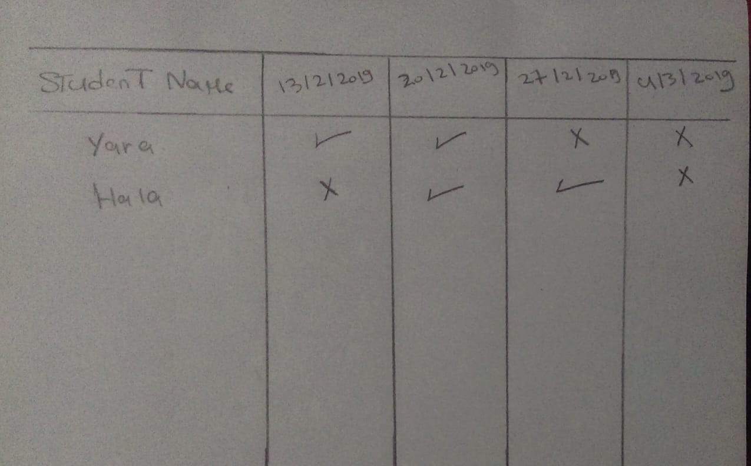

## Angular & Spring Models

|  |  |  |  |
| --- | --- | --- | --- |
| **New** | **Class Name** | AttendanceDTO | |
| **Angular Path** | | app/modules/course/shared/data/course/attendance-dto.data.ts | |
| **Spring Path** | | model/course/AttendanceDTO | |
| **Fields** | | | |
| **Attribute** | | **Angular Data Type** | **Spring Data Type** |
| attendanceDate | | Date | Date |
| students | | List<StdDTO> | StdDTO[] |

|  |  |  |  |
| --- | --- | --- | --- |
| **New** | **Class Name** | StdAttendanceDTO | |
| **Angular Path** | | app/modules/course/shared/data/std-attendance-dto.data.ts | |
| **Spring Path** | | model/course/StdAttendanceDTO | |
| **Fields** | | | |
| **Attribute** | | **Angular Data Type** | **Spring Data Type** |
| fullName | | String | String |
| attendanceDate | | Date | Date |
| isAttend | | Boolean | Boolean |

|  |  |  |  |
| --- | --- | --- | --- |
| **New** | **Class Name** | | AttendanceDTORM |
| **Spring Path** | | model/course/rm/AttendanceDTORM | |
| **Fields** | | | |

## Angular Component

|  |  |  |
| --- | --- | --- |
| **New** | **Class Name** | ViewCourseAttendance |
| **Path** | | app/modules/course/components/attendance/view-course-attendance .component.[ts/html] |

|  |  |  |
| --- | --- | --- |
| **New** | **Class Name** | AttendanceService |
| **Path** | | app/modules/course/shared/services/attendance.service.ts |
| **Function** | | getCourseAttendance (courseID: number ) |

## Rest Services

|  |  |  |  |  |  |  |
| --- | --- | --- | --- | --- | --- | --- |
| **New** | **Name** | api/course/{courseID}/attendance**/student/{stdID}** | | **Method** | | GET |
| **Controller** | | CourseRes | | **Function** | | getStudentAttendance (courseID,stdID) |
| **REST Parameter** | | | | | | |
| **Attribute** | | **Parameter Type** | **Data Type** | | **Description** | |
| courseID | | PathParameter | int | |  | |
| stdID | | PathParameter | int | |  | |

## Repository Functions

|  |  |  |  |  |
| --- | --- | --- | --- | --- |
| **New** | **Class Name** | AttendanceRep | **Type** | select SQL |
| **Function** | | getStudentAttendance (int courseID , int stdID) | | |
| **Query** | | | | |
| select first_name , last_name , created_on , is_attended  from course_std c_std left join auth_user u_std on c_std.std_id = u_std.id  left join attendance att on c_std.cor_id = att.cor_id  left join cor_std_att c_att on att.id = c_att.att_id  and u_std.id = c_att.std_id  where u_std.id =?  and c_std.cor_id = ? | | | | |